|  |
| --- |
| Department of Software Engineering  Mehran University of Engineering and Technology, Jamshoro |

|  |  |  |  |
| --- | --- | --- | --- |
| Course: SWE324 – Distributing Computing | | | |
| Instructor | Rabeea Jaffari | **Practical/Lab No.** | 01 |
| Date | 02 April 2019 | **CLOs** | CLO-4: P3 & P4 |
| Signature |  | **Assessment Score** | 1 Marks |

|  |  |
| --- | --- |
| Topic | To become Familiar with OLTP System Design |
| Objectives | * To Creating applications using Datagram sockets. |

|  |
| --- |
| Lab Discussion: Theoretical concepts and Procedural steps |

|  |
| --- |
| Lab Tasks |
| Submission Date: 09-04-19 |

1. Develop the RMI Callback application of Payroll and PayrollMessage services for calculating the earnings.

Classes:

1. payrollClient

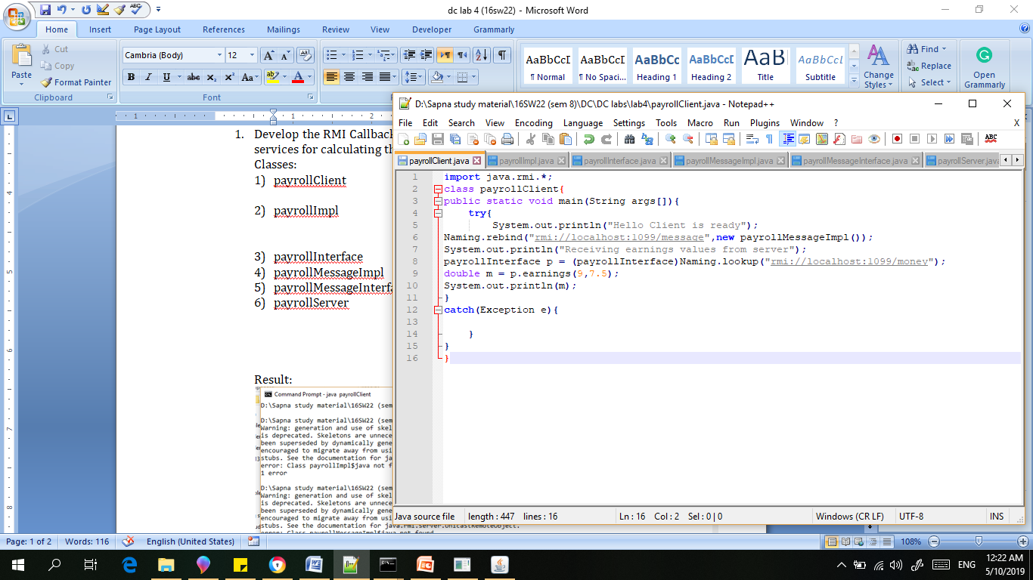

1. payrollImpl

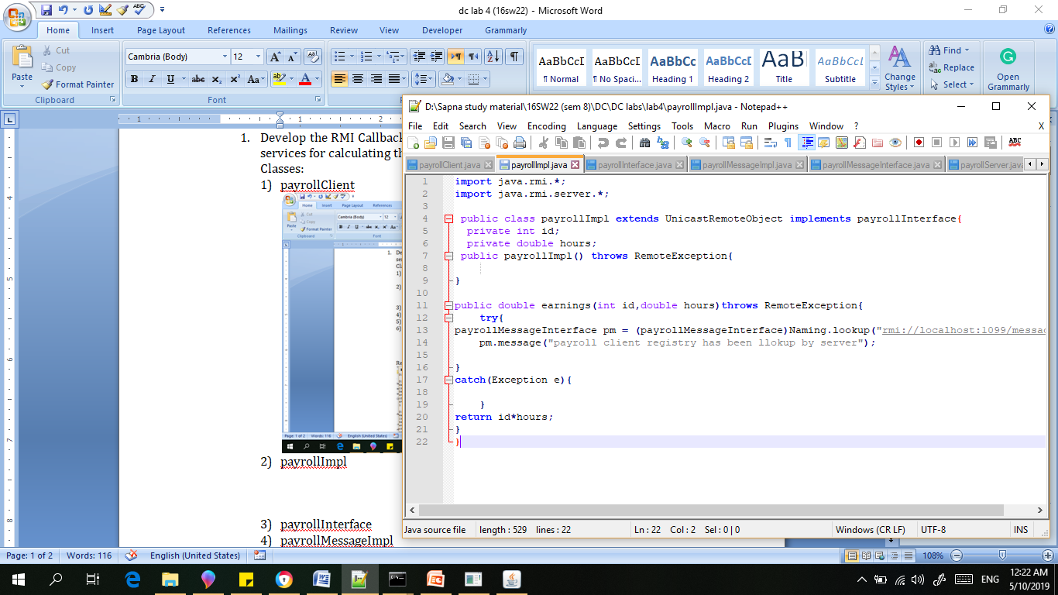

1. payrollInterface

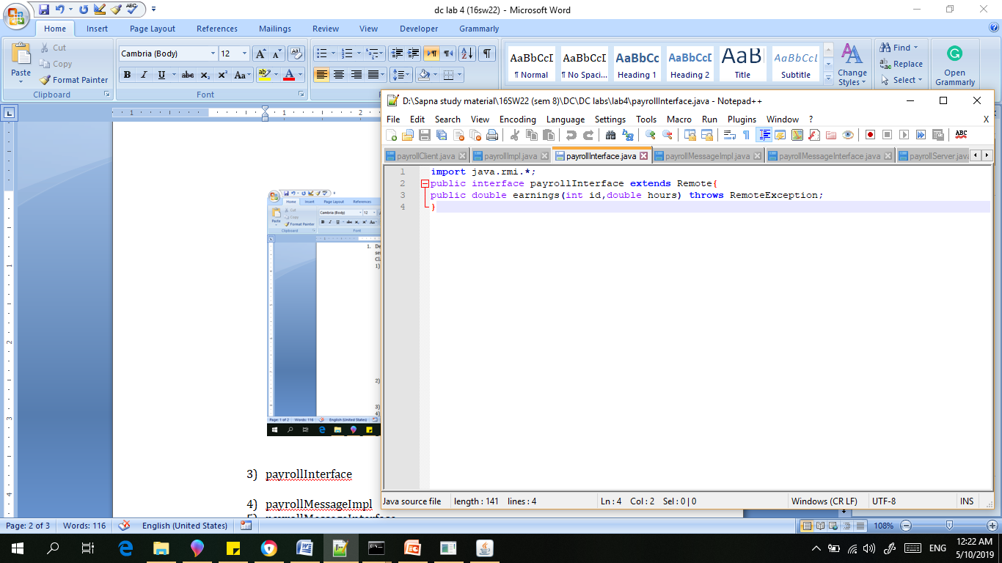

1. payrollMessageImpl

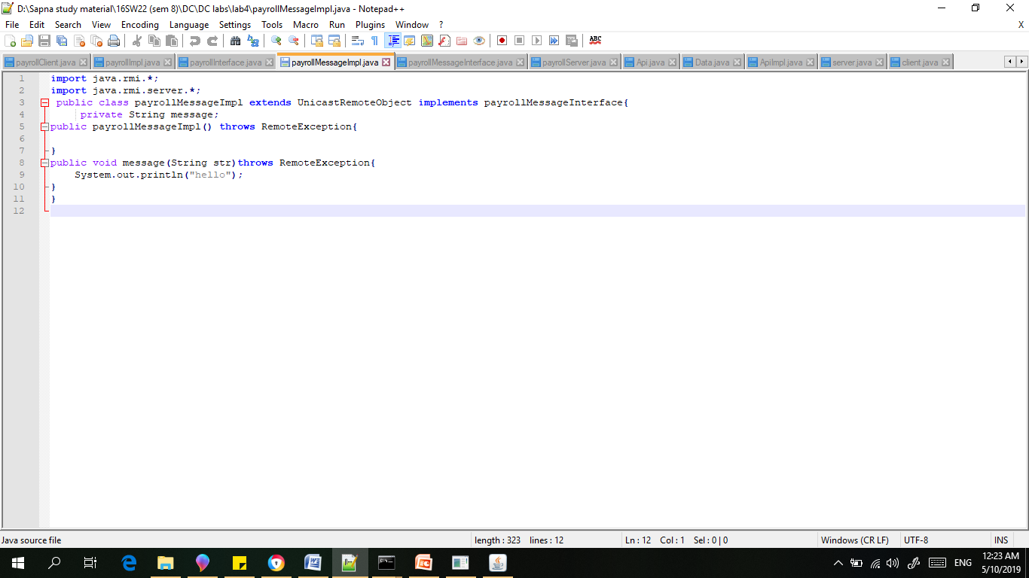

1. payrollMessageInterface

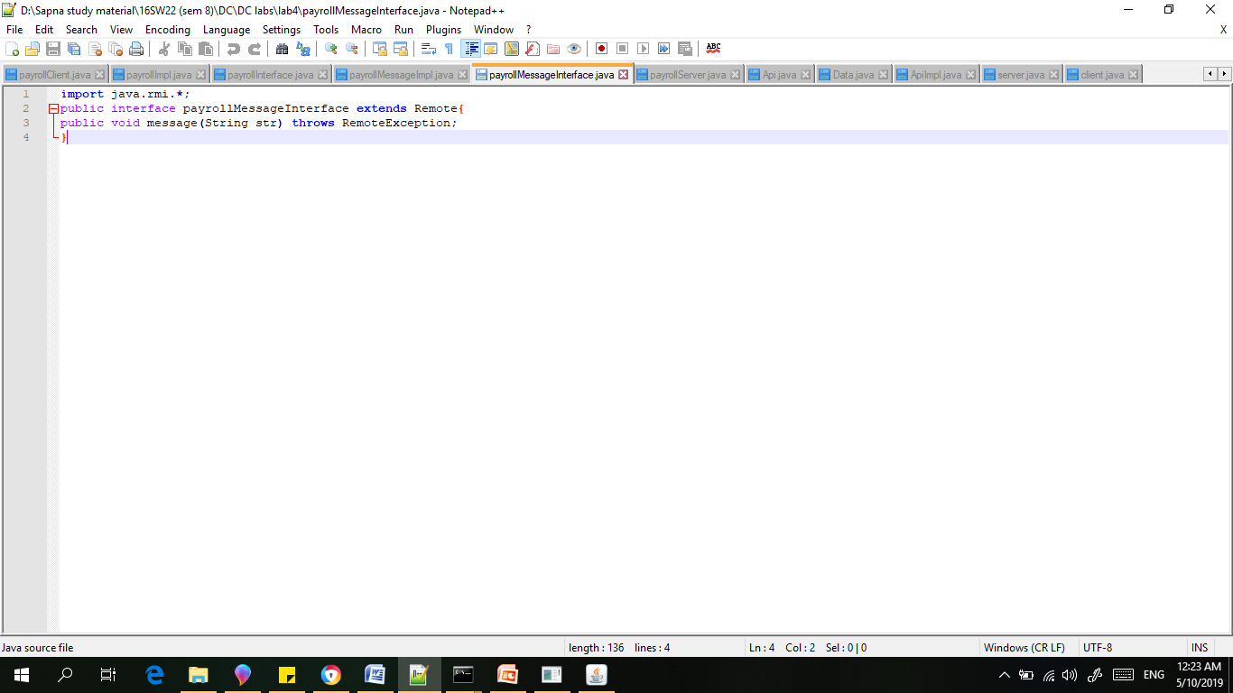

1. payrollServer

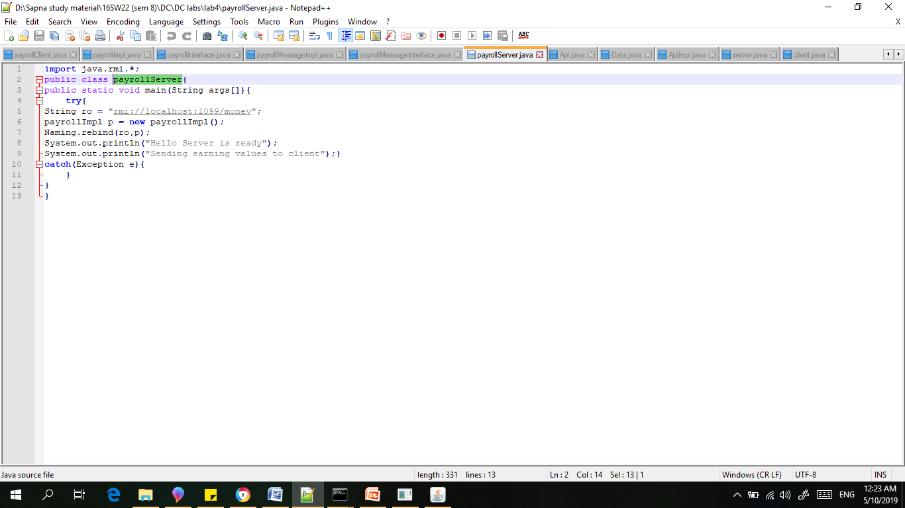

Result:

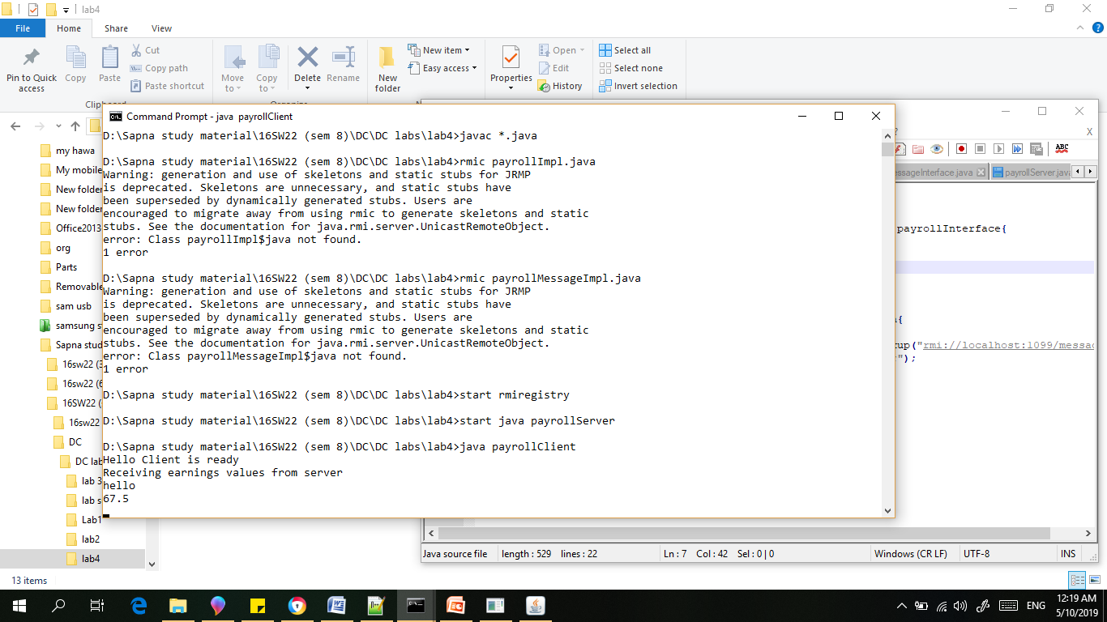

**Optional Task:**

1. Develop an RMI application for chatting between client and server, the chatting should stop when both of them say “bye”.

Code::

1. Client Class

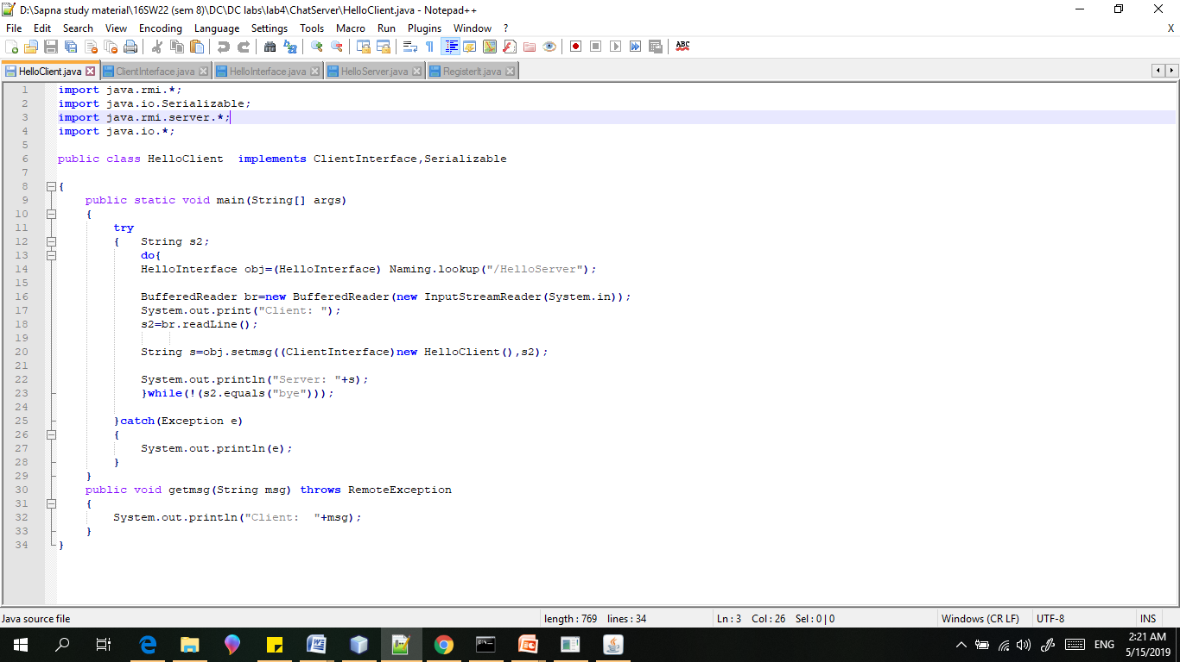

2)Client Interface:

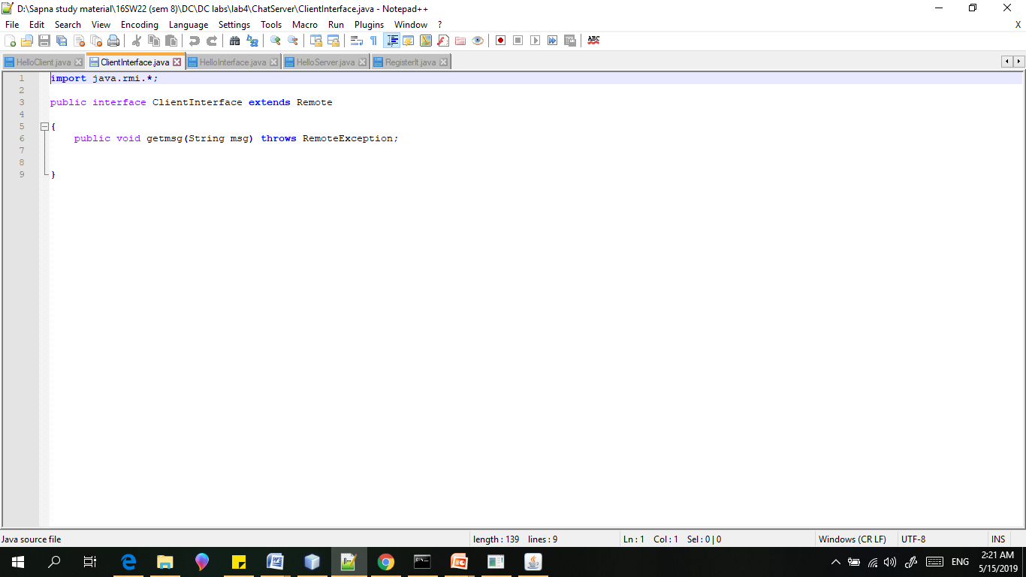

3)Hello interface:

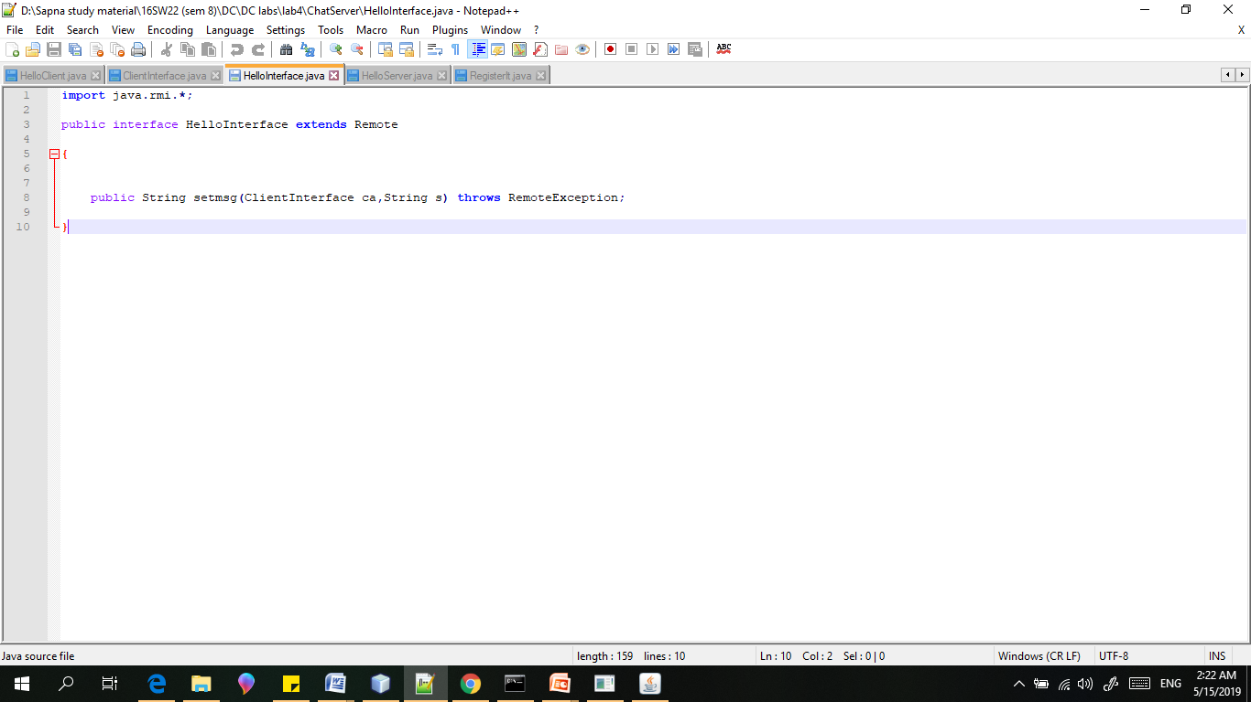

Server Class:

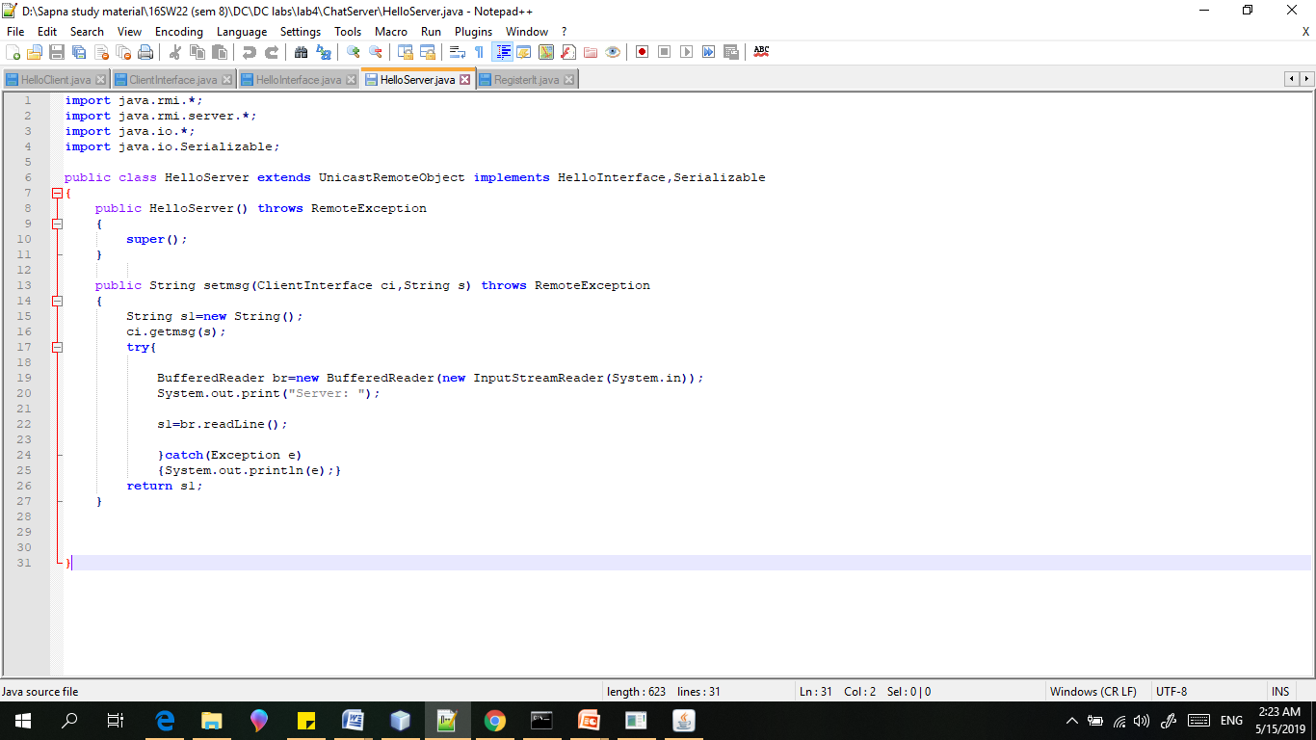

Register

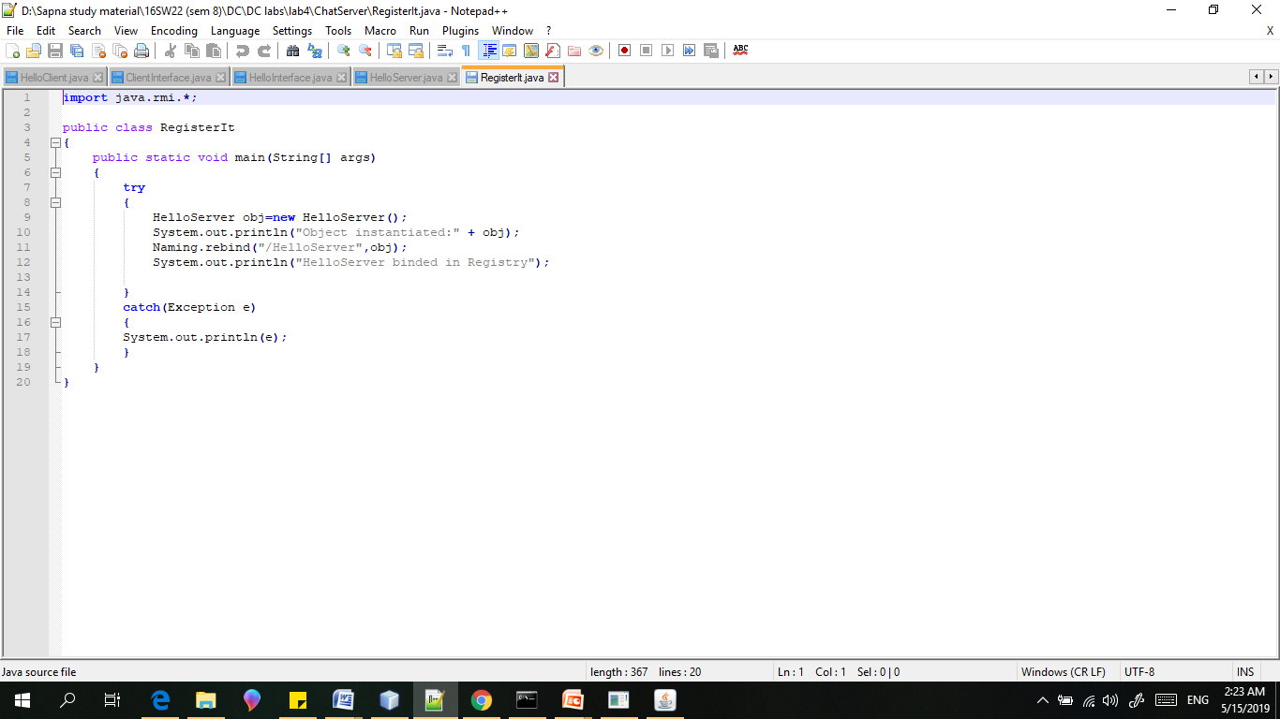

Result:

